# Image Acquisition

The first stage of any vision system is the image acquisition stage.

After the image has been obtained, various methods of processing can be applied to the image to perform the many different vision tasks required today.

However, if the image has not been acquired satisfactorily then the intended tasks may not be achievable, **even** with the aid of some form of image enhancement

* [2D Image Input](https://users.cs.cf.ac.uk/Dave.Marshall/Vision_lecture/node5.html" \l "SECTION00131000000000000000)

The basic two-dimensional image is a monochrome (greyscale) image which has been digitised.

Describe image as a two-dimensional light intensity function *f*(*x*,*y*) where *x* and *y* are spatial coordinates and the value of *f* at any point (*x*, *y*) is proportional to the brightness or grey value of the image at that point.

A digitised image is one where

* spatial and greyscale values have been made discrete.
* intensity measured across a regularly spaced grid in *x* and *y* directions
* intensities sampled to 8 bits (256 values).

For computational purposes, we may think of a digital image as a two-dimensional array where *x* and *y* index an image point. Each element in the array is called a pixel (picture element).

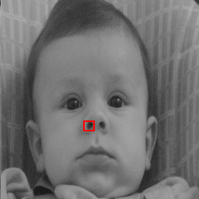

**Greyscale image and highlighted region**

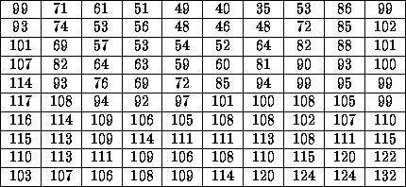

**Pixel values in highlighted region**

### **2D Input Devices**

***TV Camera or Vidicon Tube***

*A first choice for a two-dimensional image input device may be a television camera -- output is a video signal:*

* Image focused onto a photoconductive target.
* Target scanned line by line horizontally by an electron beam
* Electric current produces as the beam passes over target.
* Current proportional to the intensity of light at each point.
* Tap current to give a video signal.

*This form of device has several disadvantages.*

Limited resolution

-- finite number of scan lines (about 625) and frame rate (30 or 60 frames per second)

Distortion

* unwanted persistence between one frame and the next
* Non-linear video output with respect to light intensity.
* Non-flat target on tube.

***CCD Camera***

*By far the most popular two-dimensional imaging device is the charge-coupled device (CCD) camera.*

* Single IC device
* Consists of an array of photosensitive cells
* each cell produces an electric current dependent on the incident light falling on it.
* Video Signal Output
* Less geometric distortion
* More linear Video output.

### **Frame Stores**

Video Signal must be digitised.

A device known as a frame storeor frame grabber usually performs this task. It:

* Digitises the incoming video signal
* Samples signal into discrete pixels at appropriate intervals -- line by line.
* Samples signal into a (8 bit) digital value.
* Stores sample frame own memory.
* Frame easily transferred to computer memory or a file.